Donald Clay.

Donald Clay was born in 1918 to James and Emily Clay. In 1921, the family lived at 4 Albion Terrace, Luddendenfoot.
1921 England Census:
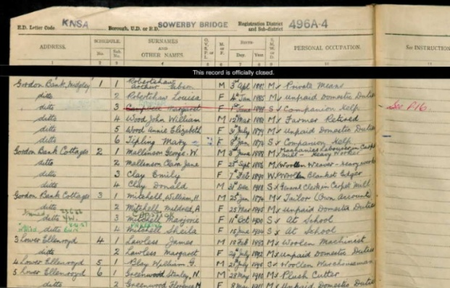
The family moved to Durban, South Africa around 1930. Donald’s father, James, took the family there as he had taken a position of manager of a woollen mill. The family returned home after James had an illness and had to give up his position. This journey turned out to be quite an adventure as the liner they were sailing on, the Winchester Castle, went ashore off Portland Bill in Dorset. This incident was recorded as below:
The Halifax Daily Courier and Guardian. Wednesday 19th February 1936.
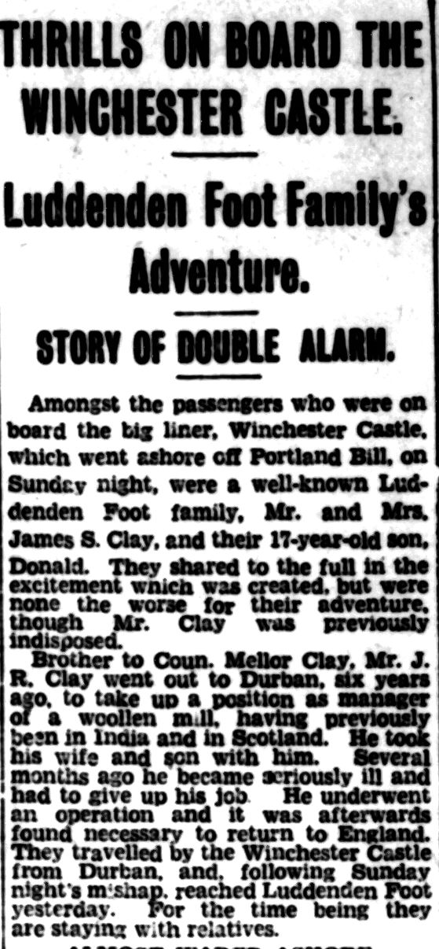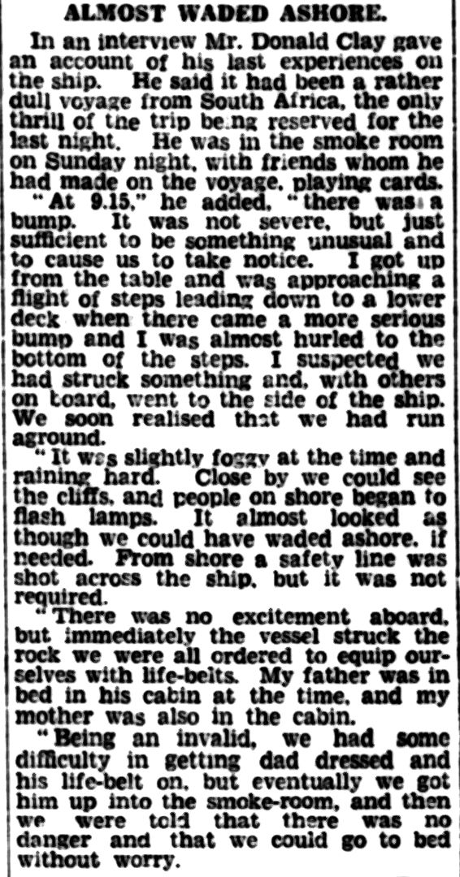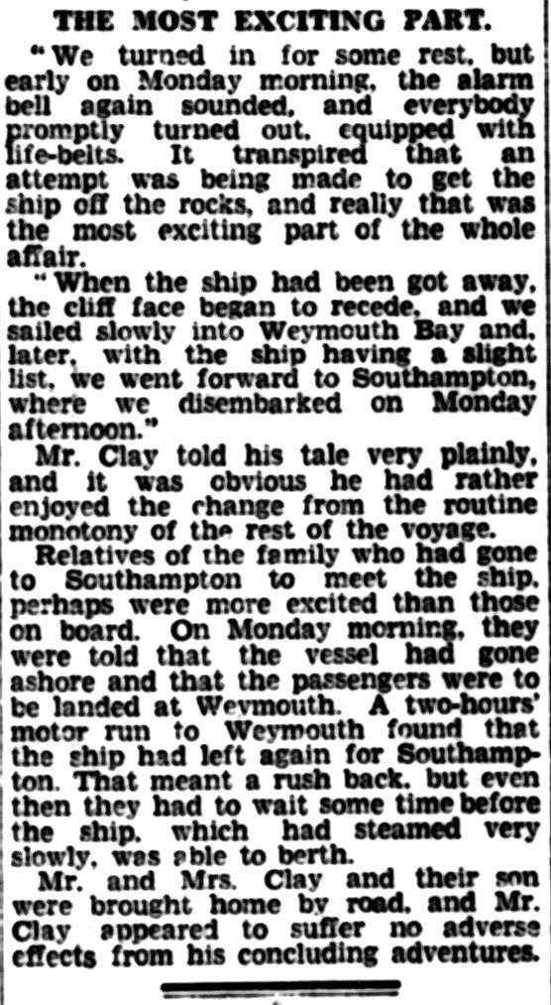

Donald’s father, James, died in 1937 and by 1939 Donald and his mother were living at 2, Gordon Bank Cottages in Luddendenfoot alongside George and Clara Mallinson.
Donald worked at Homfray and Co, Ltd in Sowerby Bridge and attended Halifax Technical College during 1938 and 1939 achieving certificates in book-keeping, Commerce, English and commercial law.
The Halifax Daily Courier and Guardian, Tuesday 16th August 1938:
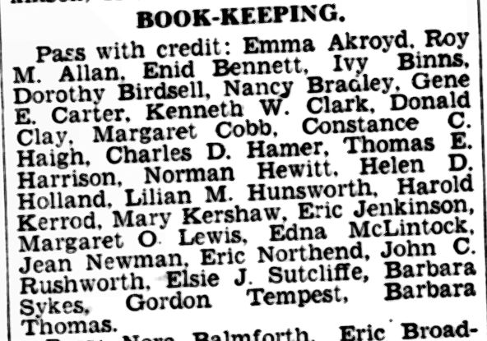
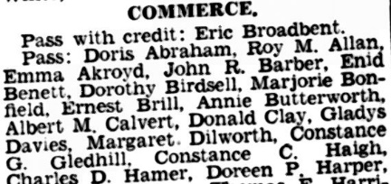

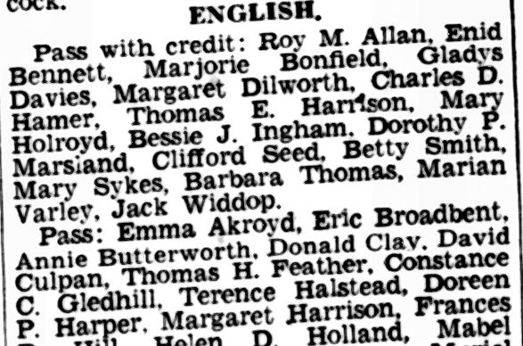
The Halifax Daily Courier and Guardian, Monday 24th July 1939:
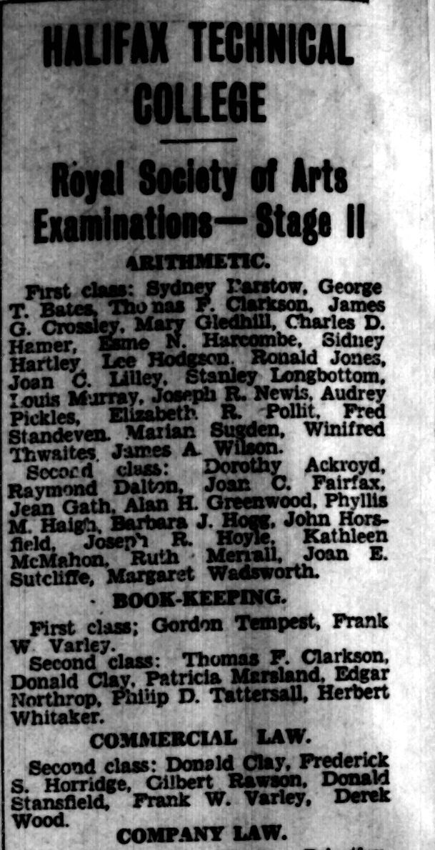
Donald was 20 years old and training in the militia when the Second War broke out.
Donald served as a corporal in the Royal Engineers 1st Supply Base, as a part of the British Expeditionary Force in France in 1940. When the Germans attacked France, Belgium and Holland, Donald’s unit was separated from the main British Force. The unit retreated through France and was still in the country after the famous Dunkirk evacuation had completed on 4th June 1940.
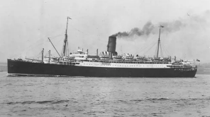
SS Lancastria.
Donald’s unit retreated to the port of St Nazaire, where Operation Aerial was underway to evacuate British troops from France. Donald boarded SS Lancastria as part of this evacuation. It is unclear how many boarded this ship but estimates range between 4,000 – 9,000. Shortly after leaving port, the ship was attacked by six Junkers Ju88 aircraft. The ship was hit by a number of bombs, listed to one side and sank within twenty minutes. Estimates range between 3,500 and 7,000 people died. Donald was one of these people.
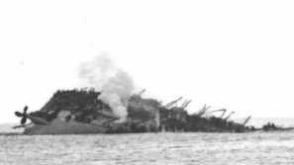
The sinking of SS Lancastria.
Concerned about morale in the country Winston Churchill censored this news, stating that the newspapers "have got quite enough disaster for today at least" forbidding the press and survivors from speaking about this tragedy.
This may be the reason that it was not until January 1942, eighteen months after the tragedy that news of his death was received.
The Halifax Daily Courier and Guardian, Friday 30th January 1942:
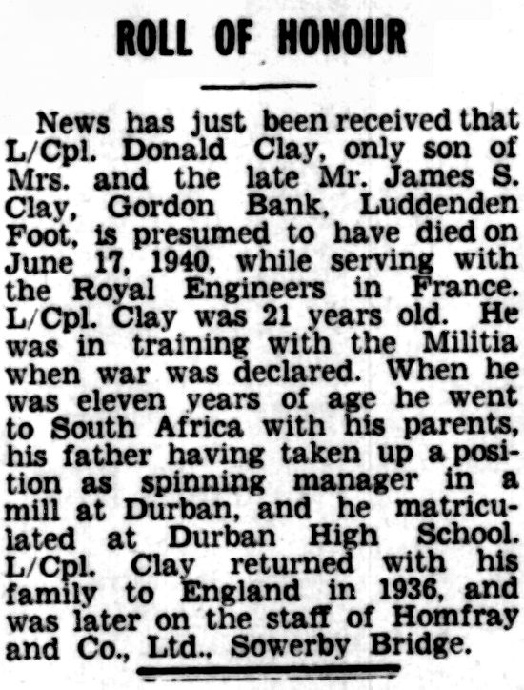
The Halifax Daily Courier and Guardian, Saturday 31st January 1942:
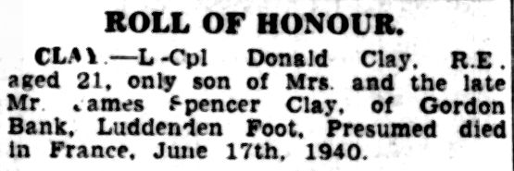

Donald is commemorated on the Dunkirk Memorial.
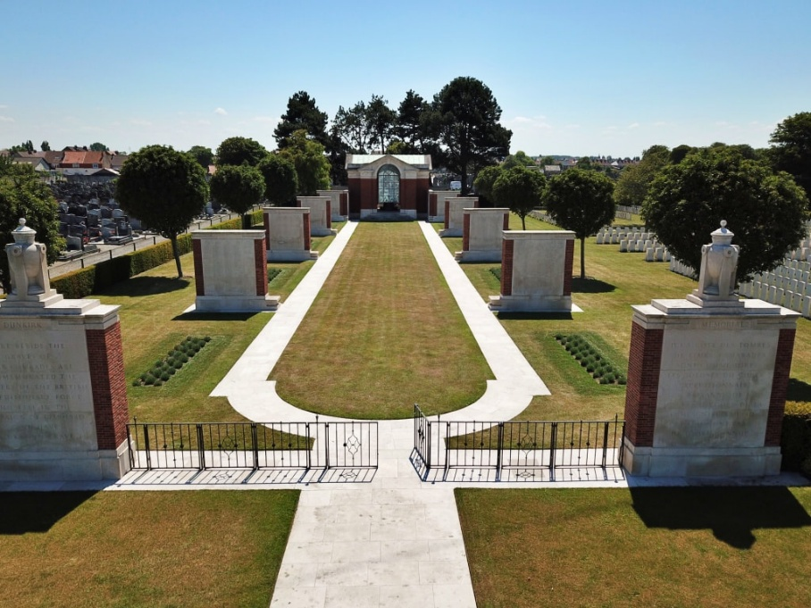
Donald died on 17th June 1940.
He was twenty-one years old.

